**Exploratory Data Analysis for Clinical and Operational data**

The motive of building this application is to give customer a base to do data analysis of data coming from various site.

**Capabilities of this application**

1. Uploading the csv file.

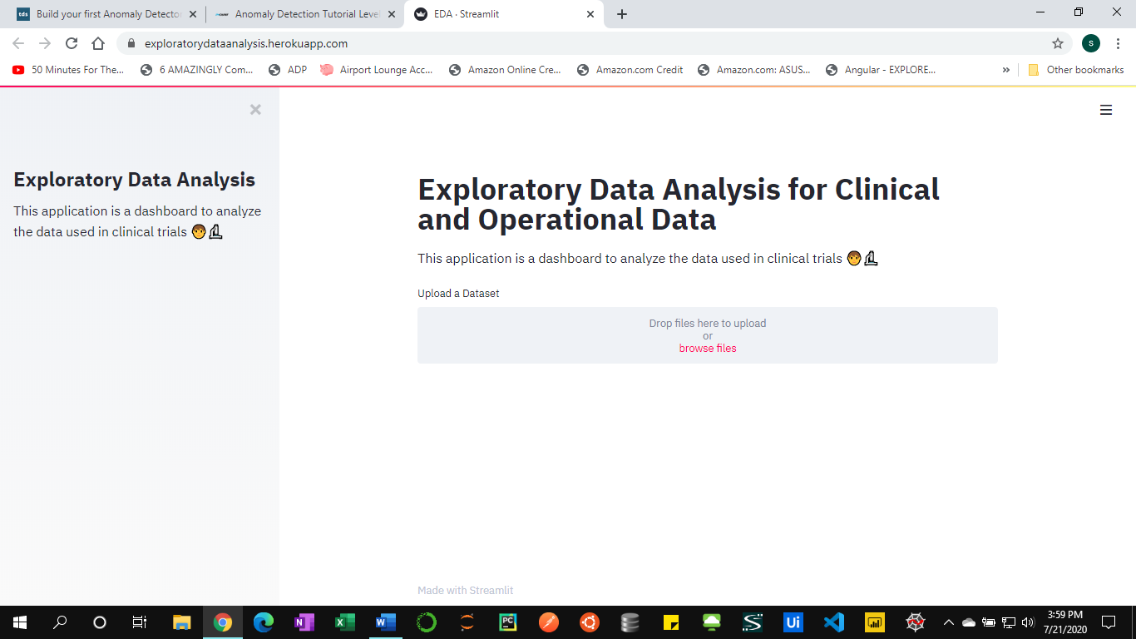

2). Viewing the dataset

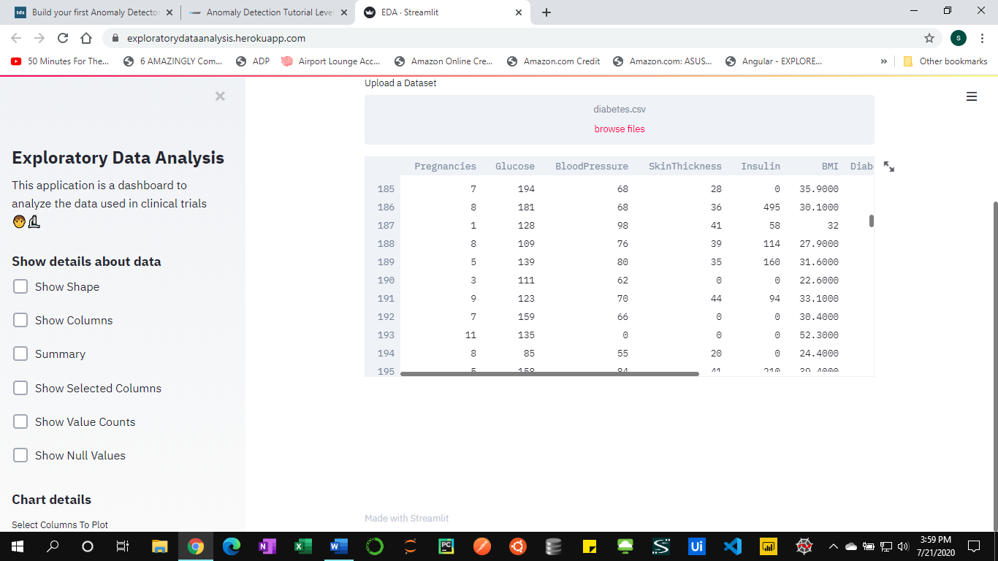

3). See the data in a full view

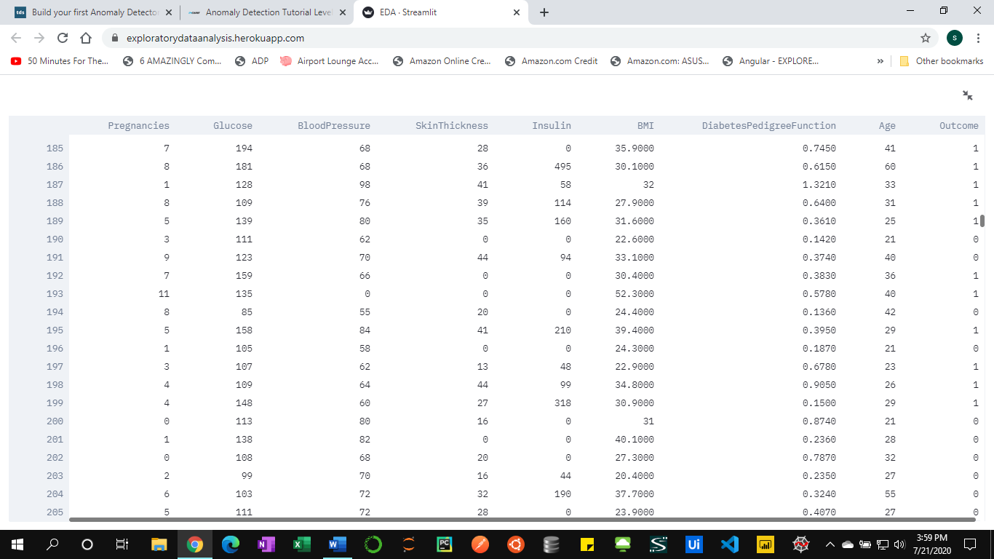

4). See the shape of the data/ check the number of rows and columns of the data.

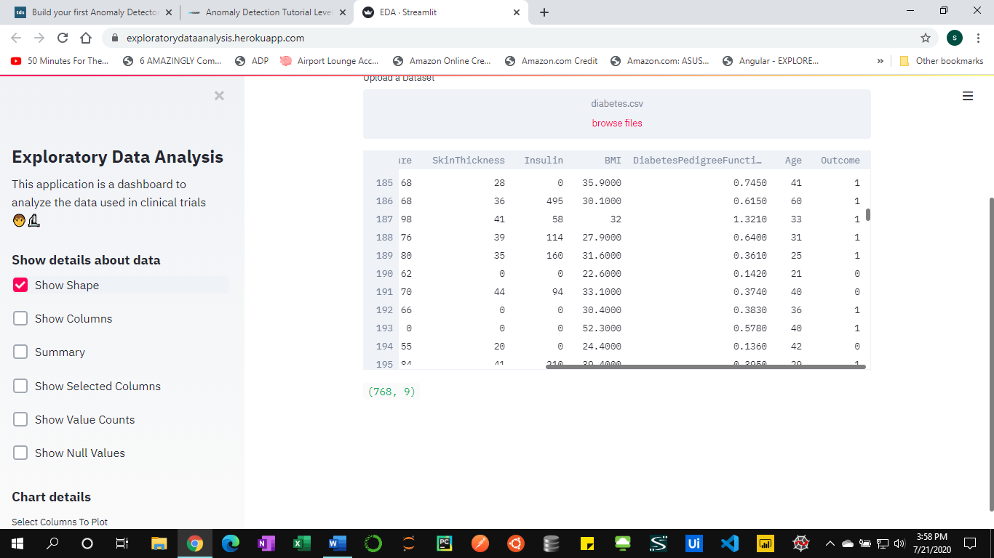

5). Get all the column names from the dataset

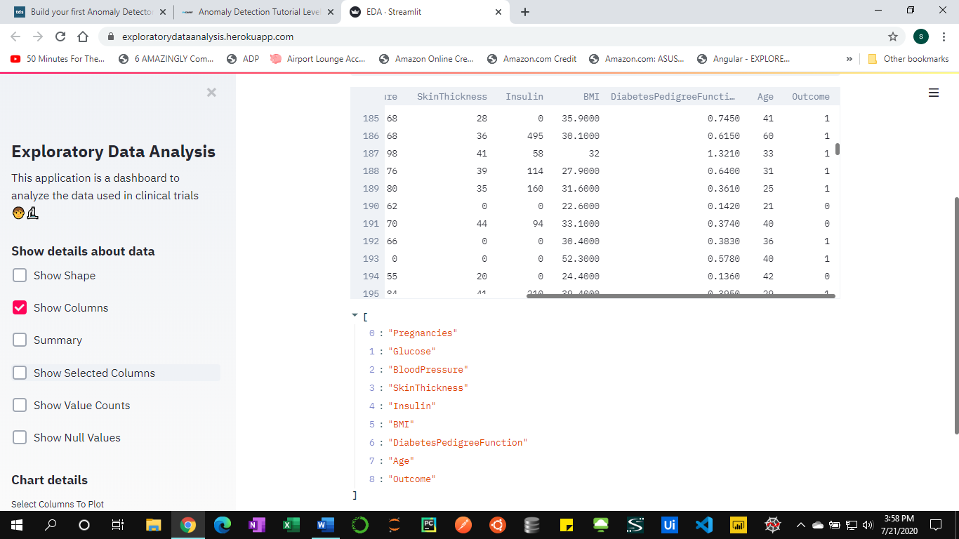

6). Get the Summary of the data (i.e. Mean, Standard Deviation & Quantile)

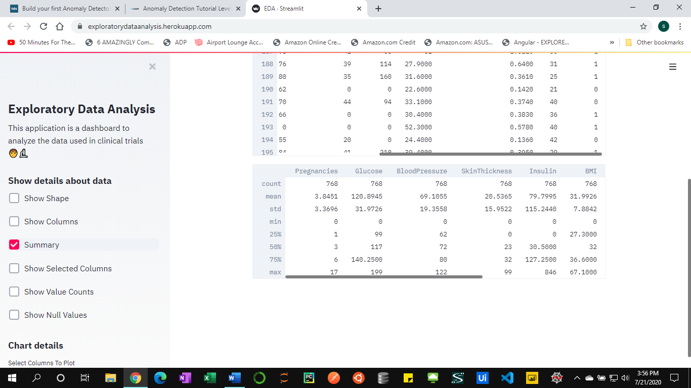

7). View Specific columns from the dataset in normal view

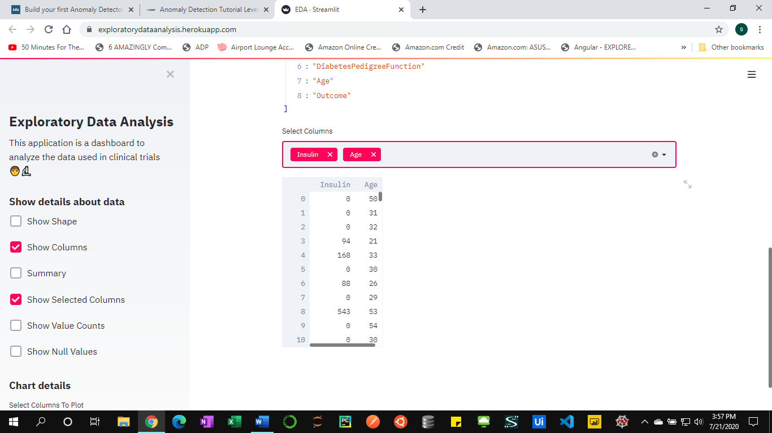

8). View Specific columns from the dataset in full screen

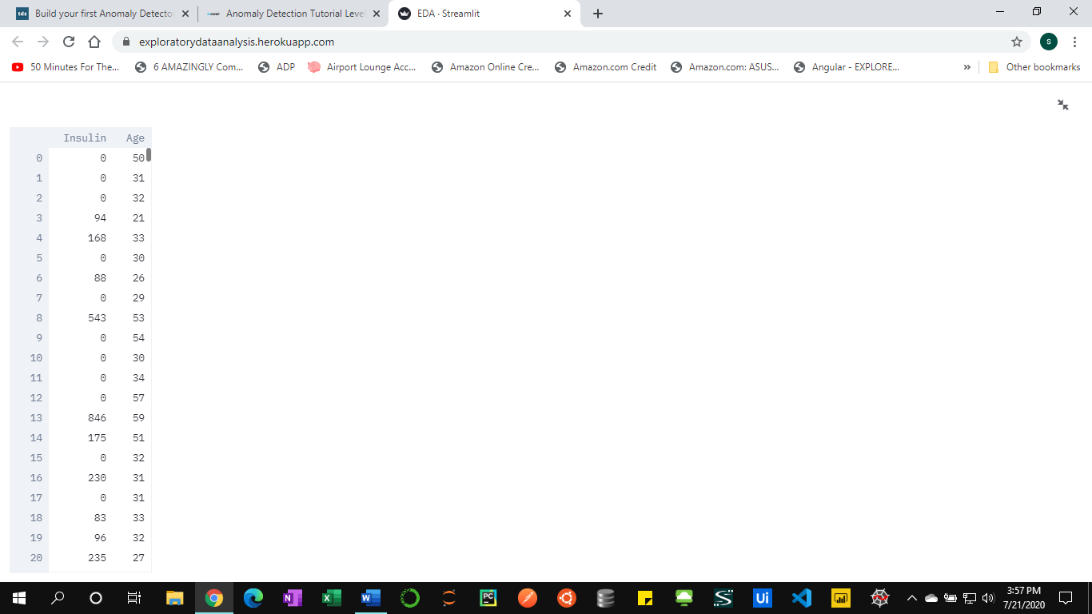

9). Get the value counts from the dataset

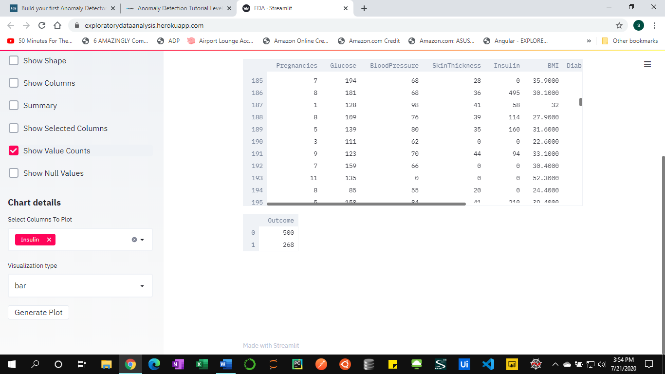

10). Display number of null values in a dataset

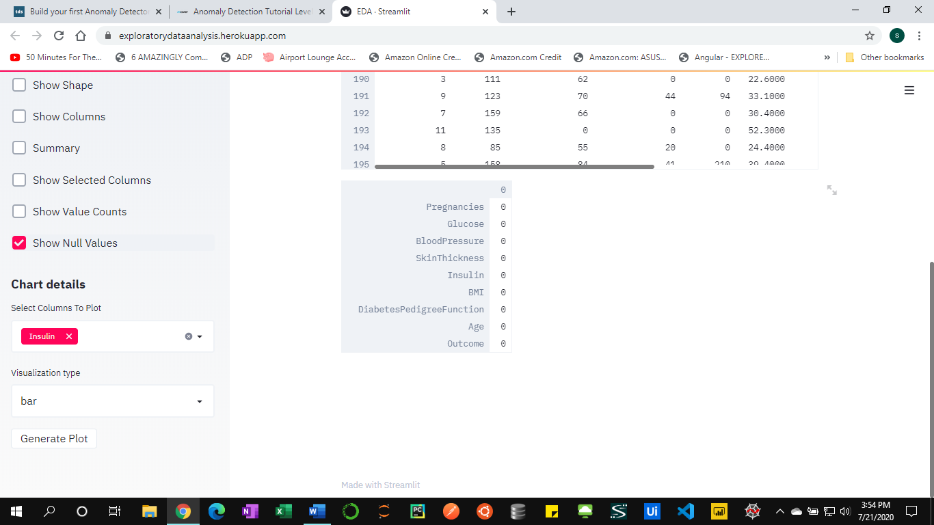

11). Build area chart for data

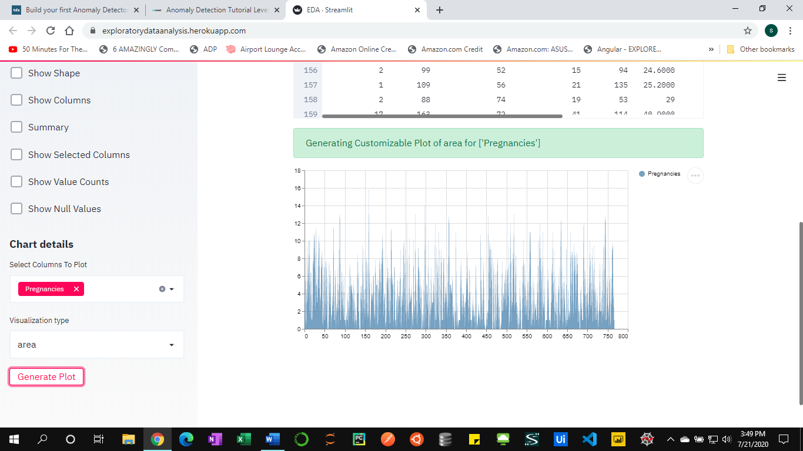

12). Build bar chart for data

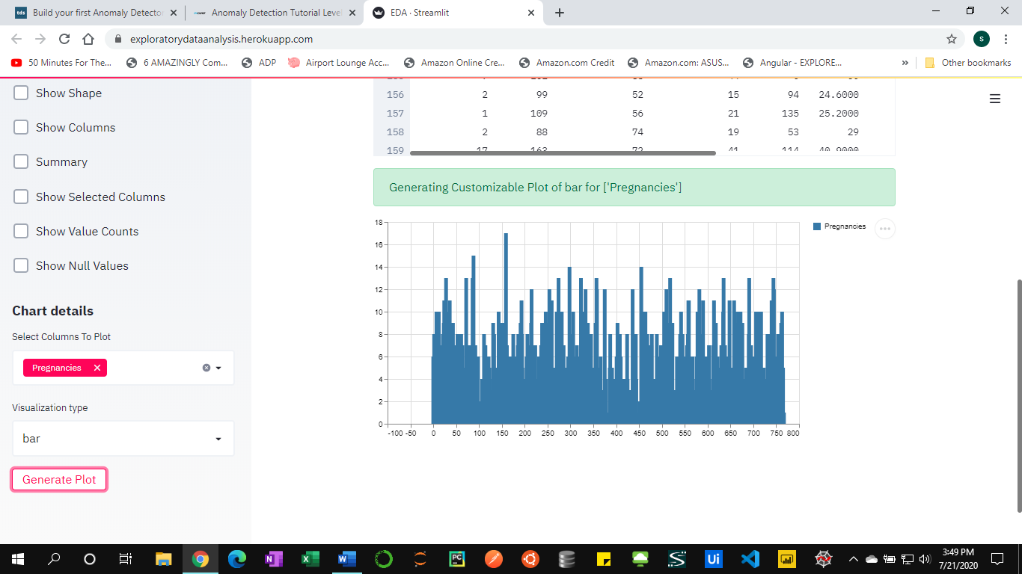

13). Build line chart for data

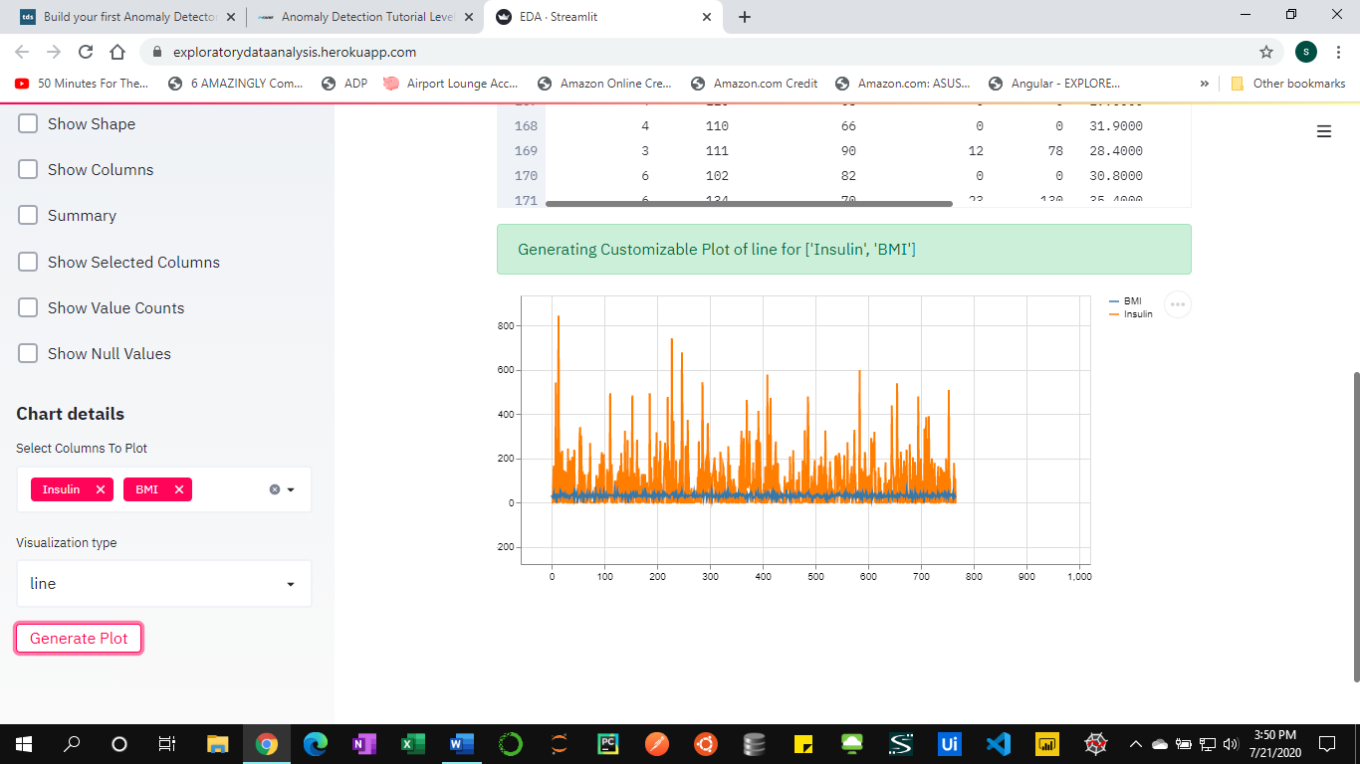

14). Build the box plot for data

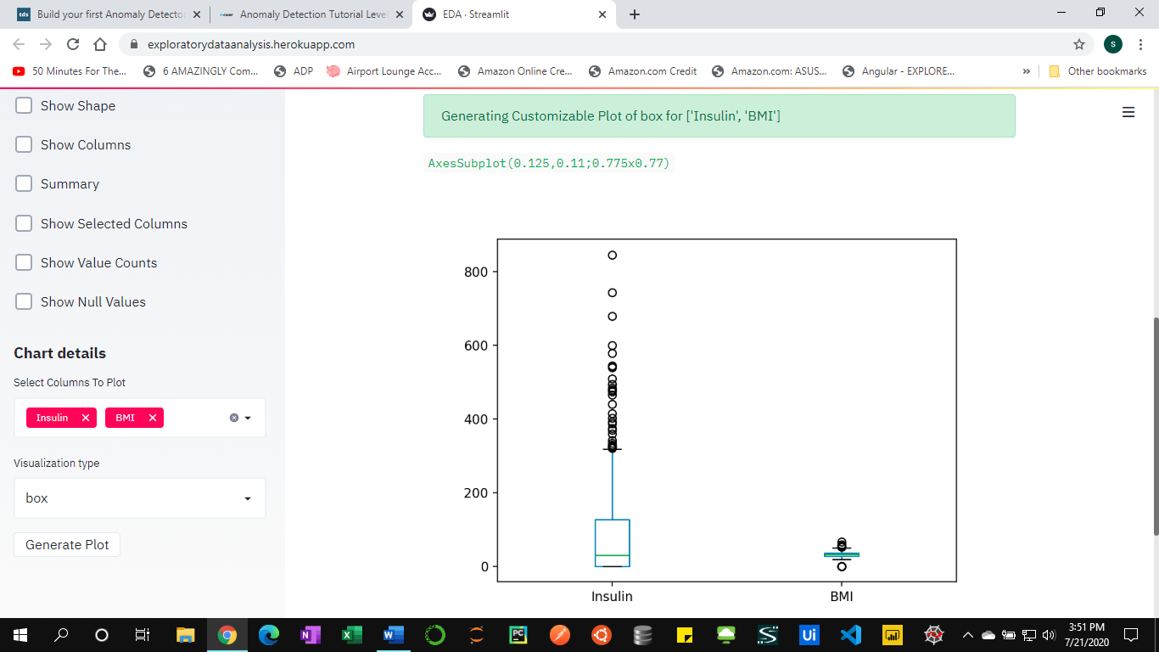

15). Options to save the chart in SVG and PNG file.

